ASSIGNMENT 3 SOLUTIONS

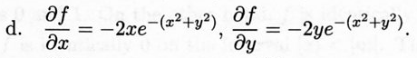
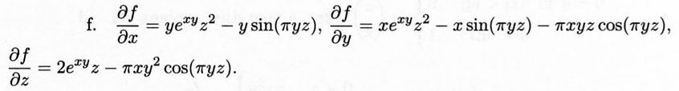

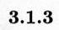
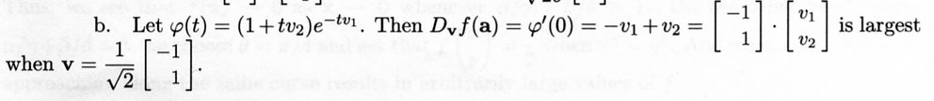

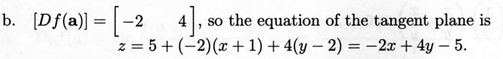
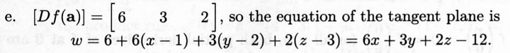

1 of 2
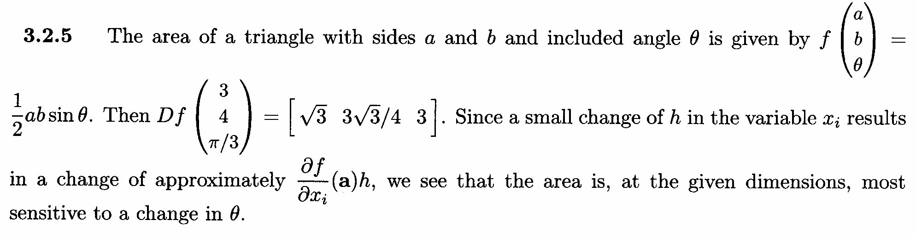

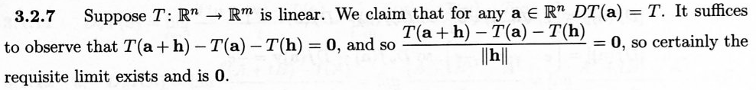
2 of 2

