ASSIGNMENT 9 SOLUTIONS

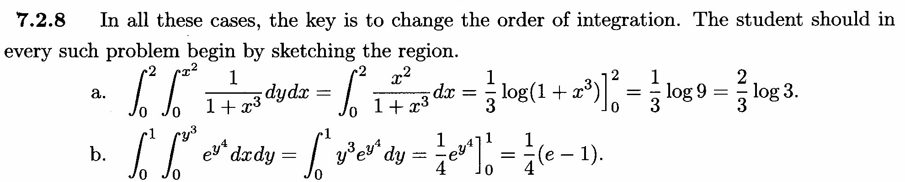

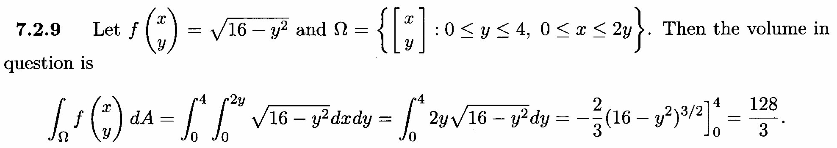
should be y/2
32
3

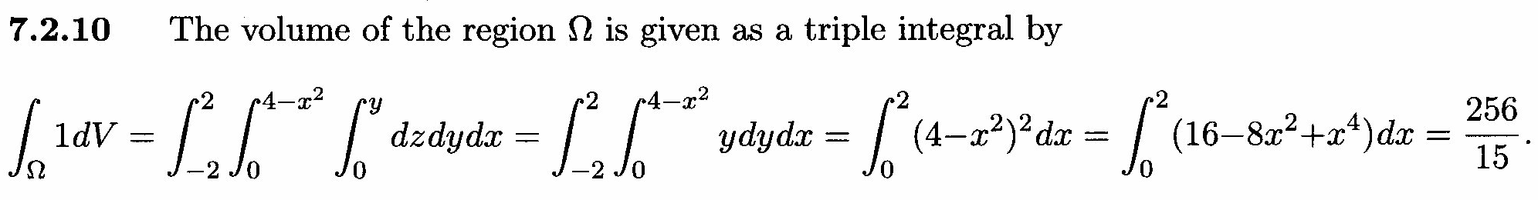

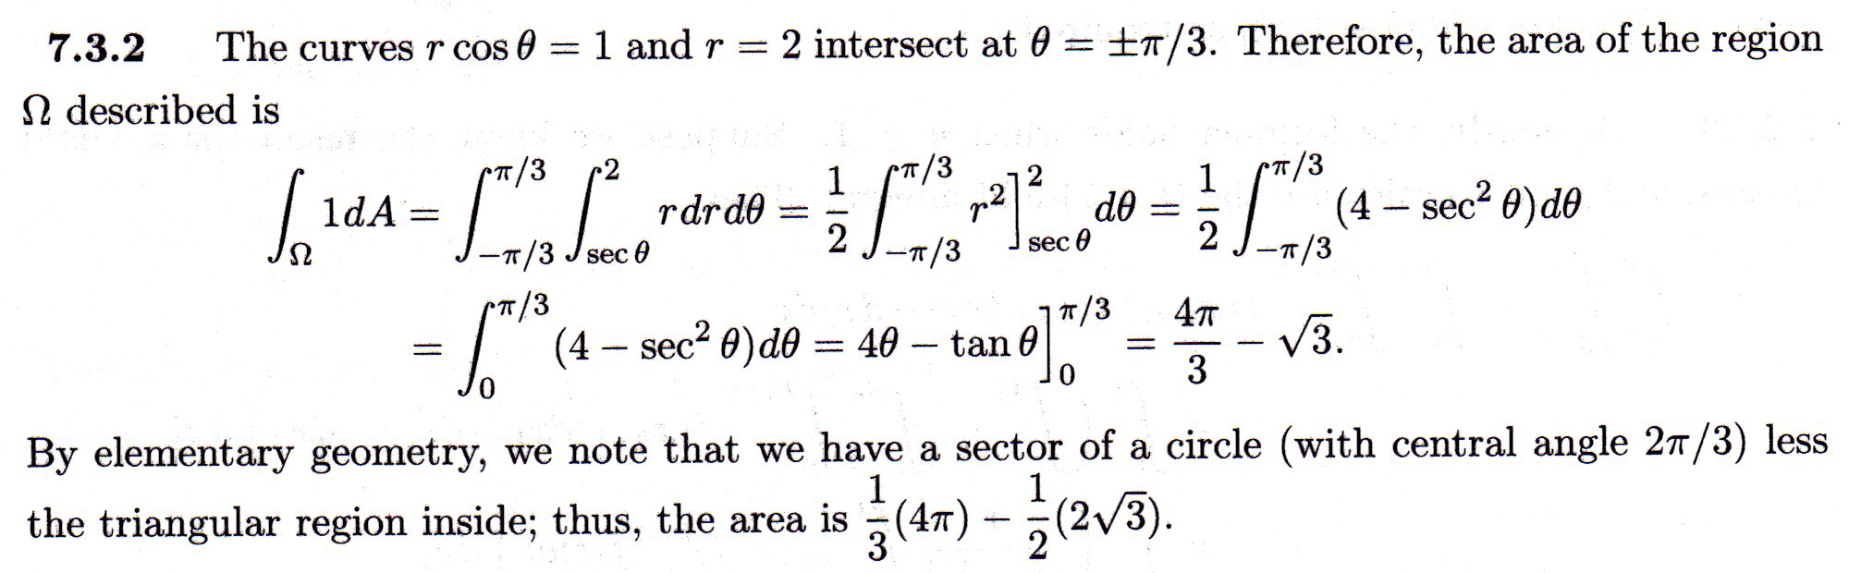

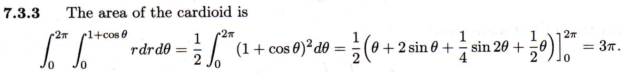
3π
2

1 of 2
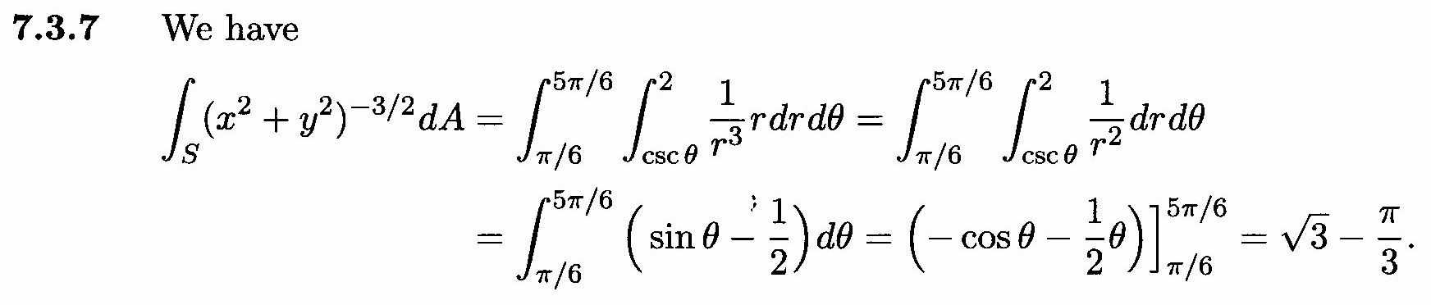

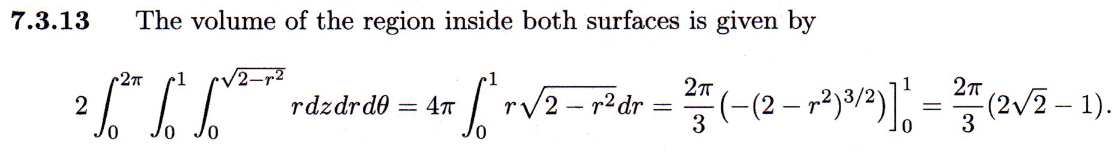
4π
4π

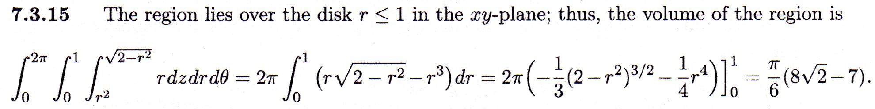

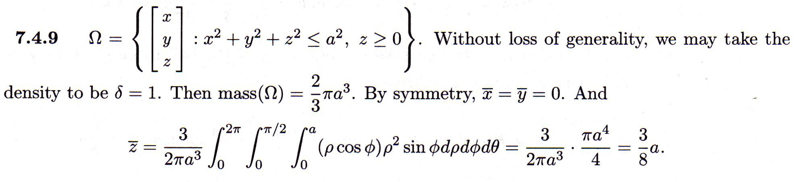
2 of 2

