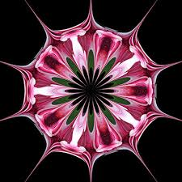

***Department of Mathematics***

***Loeb Undergraduate Lecture***







How does a chemist know that a molecule that he or she has synthesized has the desired form? Most non-biological molecules are too small to see even with the help of an electron micrograph. So chemists need to collect experimental data as evidence that a synthetic molecule has a particular form. One way is to try to match the experimental data about the symmetries of the molecule to the symmetries of a physical model of the desired form. But molecules which are not completely rigid may have symmetries that are absent from the model. Topology, which is the study of deformations of objects in space, can help interpret the data. We will explore topological and geometric approaches to studying the symmetries of complex molecular structures.

Professor Erica Flapan  
Department of Mathematics  
Pomona College

*“Topological and Geometric Symmetries of Molecular Structures”*

Wednesday, March 22, 2017

Hillman Hall, Room 70  
 4:30 p.m.

Refreshments and Snacks,   
3:45 p.m.  
Cupples I Hall, room 200