Galapagos Tortoise Programme

**Tortoise profile: A year in the life of Anne**

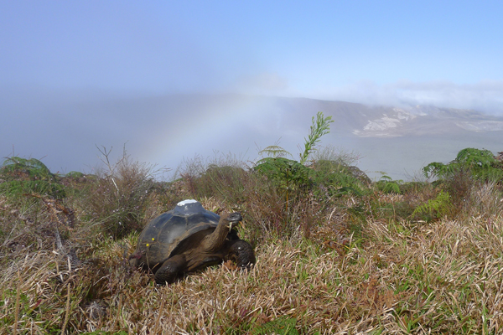

Anne seen here on the rim of Alcedo Volcano on Isabela Island. This habitat provides her with lots of grass forage which sustains her through most of the year. When the rainy season hits, she leaves for a few months to feed and lay egg at the bottom of the crater.

## Highlights

### *Galapagos tortoises*

* Are the largest terrestrial reptiles on earth
* Weigh up to 300kg
* May live for more than 150 years
* Colonized Galapagos from South America some 2-3 million years ago
* Once occurred on 10 islands. Today, wild tortoises are found on just 6 islands
* May have comprised 15 species, while today only 11 are recognized

### *Galapagos Tortoise Programme*

* + First GPS telemetry study of giant tortoises
  + 46 individuals tagged and monitored from 4 species
  + View movement data on [movebank.org](http://www.movebank.org)

### *Anne facts*

* Lives on Alcedo Volcano, Isabela Island
* Tagged in September 2010
* About 40 years old
* Tag ID 1380
* 5904 locations
* Migration specialist

**Who is Anne?**

Anne, the Galapagos tortoise, lives on one of the most spectacular, peaceful and beautiful places on earth. Anne was fitted with a GPS tracking device in 2010, and we have followed her movements every single hour since then. She was tagged on a wonderful day (photo above), with a rainbow in the background overlooking the vast crater of Alcedo. She was a beautiful animal, which is why we decided to call her Anne, in memory of Charles Darwin’s daughter. Anne Darwin (Annie, bottom right image) was “the apple of her father’s eye”, and was apparently a wonderful little girl. When just eight years old she caught scarlet fever, and after two long years of suffering she died in 1851. Poor Charles and Emma Darwin were heartbroken. It is doubtful, but possible that Anne, the Alcedo tortoise, was already alive when Anne Darwin died. We are pleased to think that a free spirited tortoise is wandering over the landscape of Alcedo bearing her name in her memory. There can be no doubt that it is in large part thanks to Charles Darwin that there are tortoises like Anne still alive today.

Just a few years ago, Alcedo was dying as an ecosystem. Feral goats rampaging over the island eating every scrap of green vegetation they could find. There were destroying the tortoise habitat, leading to famine, erosion, and turning lush pastures into barren wastelands. The Galapagos National Park Service and Charles Darwin Foundation acted decisively, eradicating every single goat from Alcedo in the late 2000s.Thanks to their efforts, Anne the tortoise can rest easy, live in peace, and hopefully inspire generations to care for Galapagos nature.

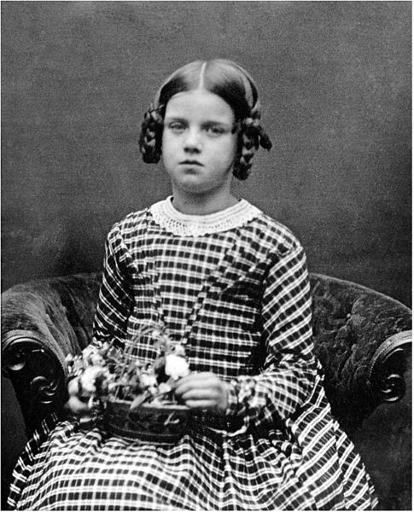

**What did Anne do this year?**

**A year in the life of Anne**

So Anne started her year on the southern rim of Alcedo, right on the top of the mountain. She spent the first couple of months there enjoying the lush grass, just wandering back and forth along the volcano rim, feeding. Her goal was probably to put on as much weight as possible to get herself ready for her migration down into the crater floor to the wet season feeding grounds and nesting areas. The rains on Galapagos start around about late December and January, and by February, the vegetation on the islands responds and becomes green and nutritious. That seems to be the signal for the tortoises to change their lifestyle and go “walkabout”. Right around the end of February Anne decides its time, and she quickly (for a tortoise) goes into migration mode. She walked down the steep rim of the volcano into the caldera (crater). In some places the slope is so steep that she probably tobogganed by putting her legs into her shell and sliding down the dry soil. Once on the flat bottom, she walked around the edge to the northeast, probably joined by a large number of other tortoises all doing the same thing. After visiting some fumaroles (huge holes in the crust of the volcano that let out gas and steam), she went right out into the heart of the crater. Only she knows why, because it looks pretty inhospitable out there, but maybe she knows of a nice patch of sandy soil for egg laying. Just as she got to the furthest point from her old feeding ground on the rim, she decided it was time to turn around, and head back. You can see from the graph that she made it all the way back between 1st May to 15th June. But then, she turned right around and headed off again!! Maybe she had some eggs to lay that she’d forgotten about? Maybe it rained again and she wanted to feed in the best vegetation back in the caldera? Again, for the moment only she knows. Finally she began a long trudge home to the rim climbing once more up the steep slopes of the caldera, to her dry season refuge.

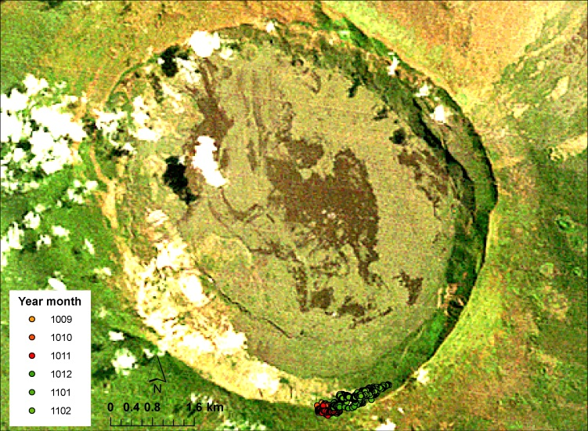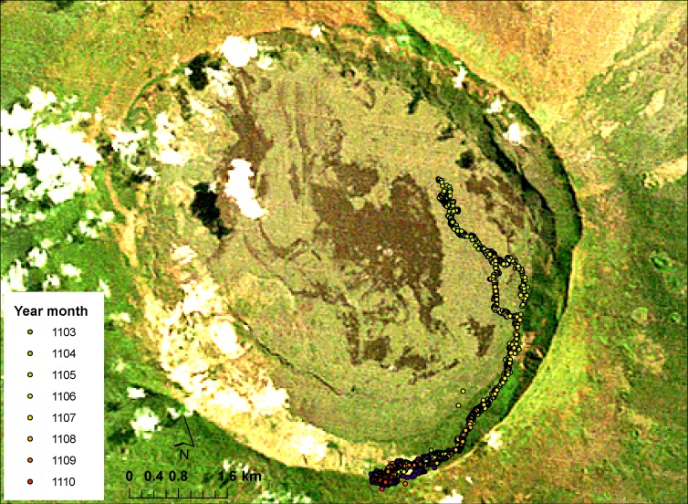

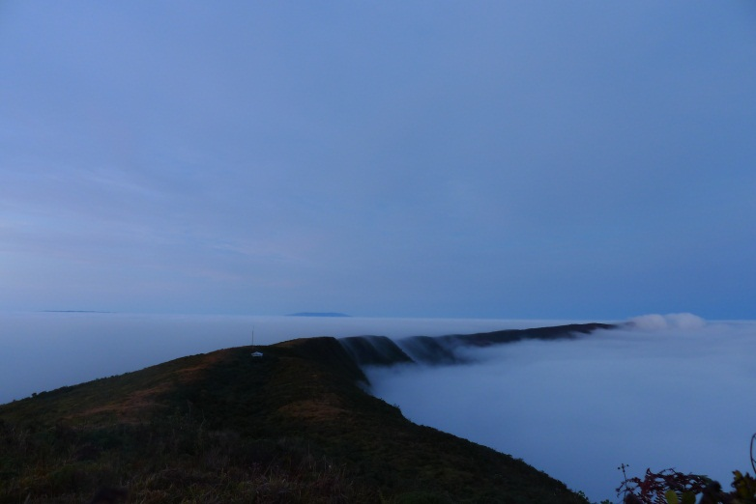

So think of Anne now and again, up there in the beauty of the early morning as the clouds billow over the edge of the crater like some prehistoric wonder. Think too about that little girl who died more than 100 years ago, and broke the heart of one of the greatest scientists who ever lived, who championed question and trying to understand what he saw around him. I, like Darwin, you are curious about giant tortoises, and Anne the tortoise in particular, check out her up to date movements by downloading her latest data from [www.movebank.org](http://www.movebank.org) and plotting them out as a movie on googleearth!! Its wild!